* **personal achievement and activities** 
  + **Formal Education**

Early Childhood Studies program — BA degree June 2020 - April 2023

Ryerson University

Early Childhood Education Program — **Diploma** September 2014 to May 2016

George Brown College, Toronto

* + **Work Experience**

**Bilingual teachers - Kindergarten October 2020 - March 2021**

Rong Qiao Sedbergh School - No. 466, Jinbin Road, Binhai New City, ChangleDistrict, Fuzhou, Fujian, China

**RECE – Junior Preschool December 2017- November 2019**

Today's Child-Tomorrow's Future Day Care Centre - 725 Danforth Rd, Scarborough, ON M1K 1G4

**Lead Teacher – Junior Preschool October 2016 to November 2017**

Angel Child Care Learning Centre - 25 Thunder Grove, Scarborough, ON M1V 3M2

**Supply ECE - School age, Toddler and Kindergarten July 2016 to Oct 2016**

Learning Jungle Kennedy Daycare - 3376 Kennedy Rd #101, Scarborough, ON M1V 3S8

* + **Placement Experience**

**Student Early Childhood Educator (LAB school)-Infant Jan2016 to Feb2016**

Child Care in University of Toronto on Charles-35 Charles St W, Toronto, ON M4Y 2R4

**Student Early Childhood Educator - Kindergarten Sept 2015 to Oct 2015**

Rolph Road Public School –31 Rolph Rd, East York, ON M4G 3M5

**Student Early Childhood Educator -Toddler March 2015 to April 2015**

Sunnybrook Creche –2075 Bayview Ave, Toronto, ON M4N 3M5

**Student Early Childhood Educator –Preschool Nov 2014 to Dec 2014**

Davisville Early Learning and Child Care Centre –41 Millwood Rd, ON M4S 1J6

* + **Professional Certificate**

**Registered Early Childhood Educator**

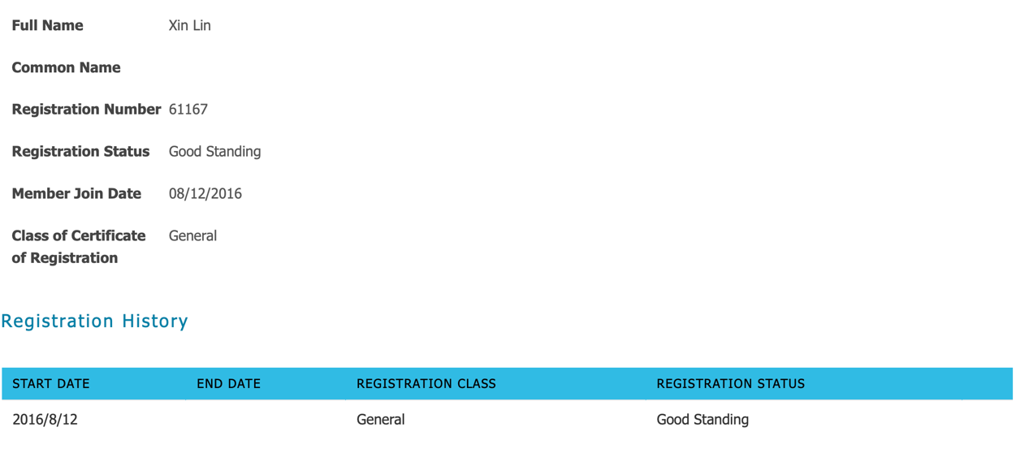

**Standard First Aid & CPR/AED Level C Certificate**



* + **Professional Development**

Commit to Kids - Child Sexual Abuse Prevention Training for those Working with Children

March 2022



Everyday Parenting: The ABCs of Child Rearing February 2020

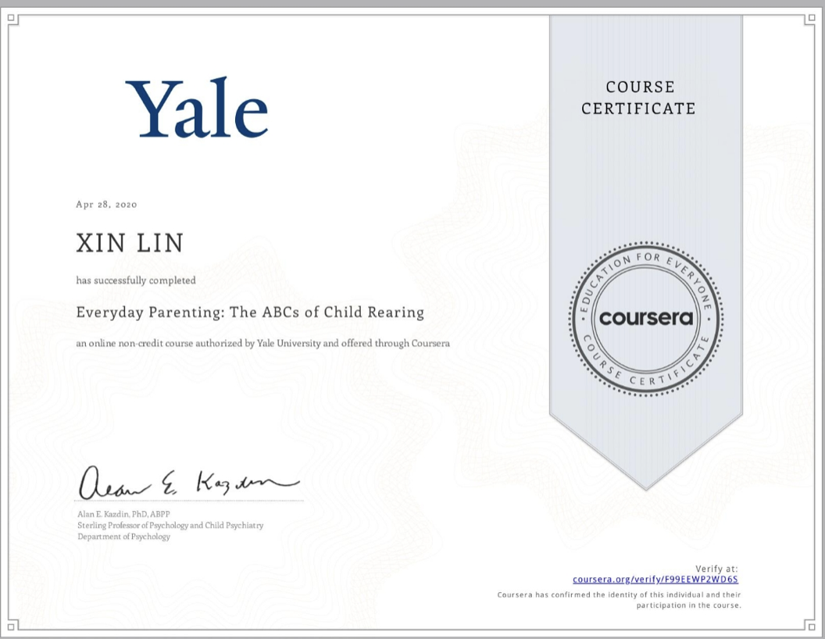

Managing Asthma, Allergies, Diabetes, and Seizures in School. March 2020

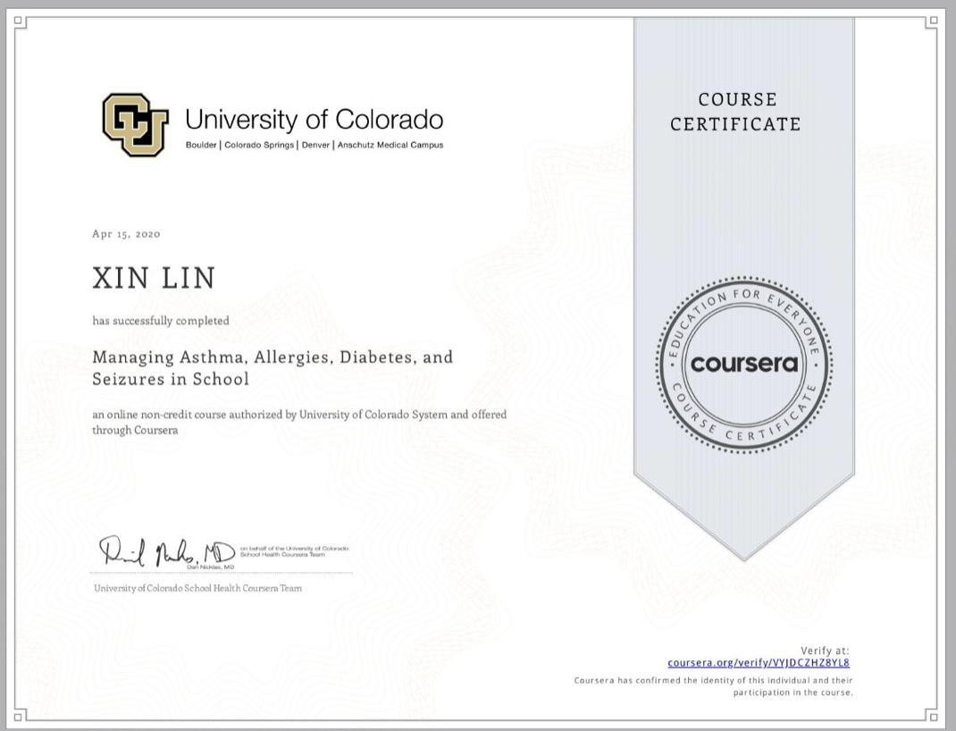

Managing ADHD, Autism, Learning Disabilities, and Concussion in School April 2020

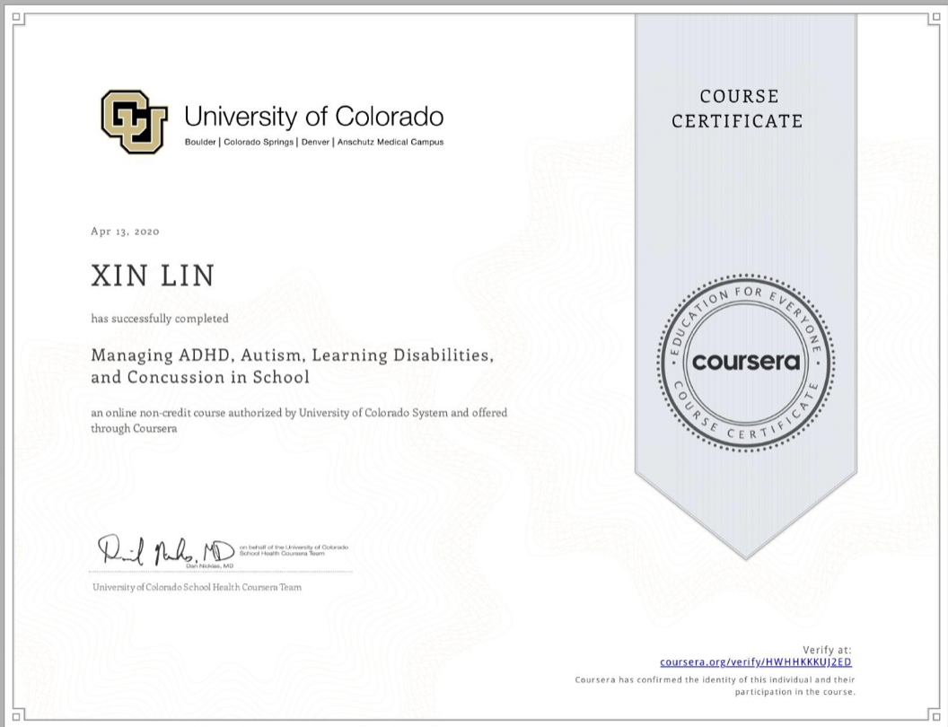

Autism Spectrum Disorder January 2020

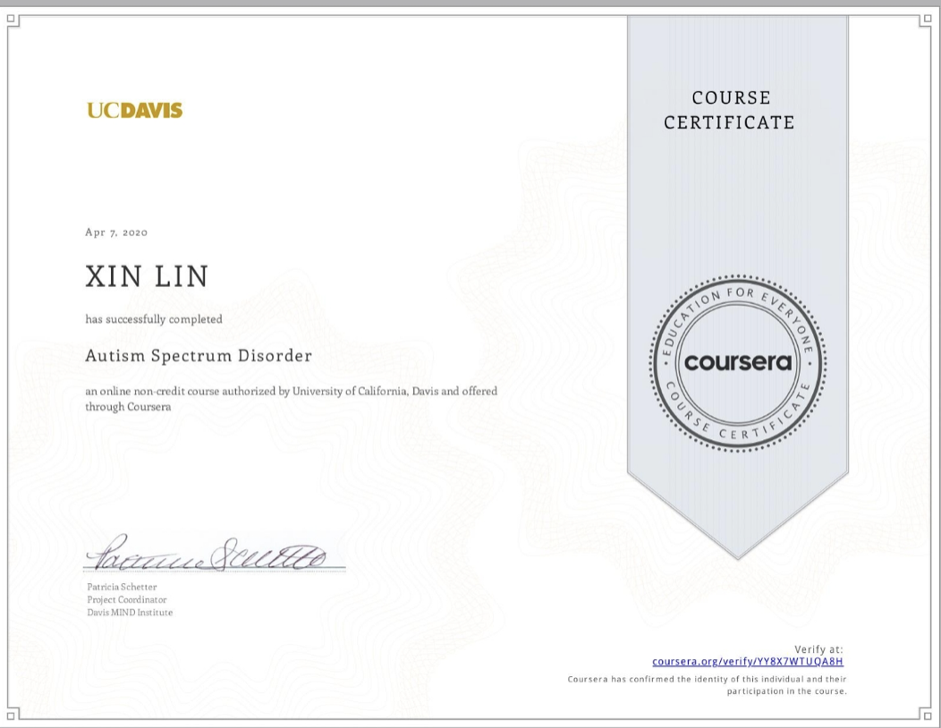

Workshop: Coping with Emotions February 19, 2019

Workshop: Discover, Understand, Support: The Unseen Sensory System Behind Childrens' BehavioursFebruary 21, 2019

Workshop: Behavior Management: The Tricks and Tools January 31, 2018

Workshop: AQI Community of Practice April 10, 2017

Workshop: Behavioral Management April 27, 2017

Workshop: Foundations for Learning Series Part 1 & 3 October 16, October 30, 2017

ADHD: Everyday Strategies for Elementary Students. November 2015

Child Abuse Course-George Brown College November 2015

* **activity plan** 
  + **Ryerson ECS Placement Plans**

**Bubble Art:**

This activity is planned to take place outdoors on the playground, the children will be provided with four sensory tables filled with bubble solution and food colouring. Each bin will be filled with a different colour. We will provide the children with bubble wands and straws to manipulate the bubble solution. Children will first be introduced to some colour art from different cultural groups’ artists, and then be encouraged to create their own artwork with soapy water. The children can then blow the bubbles onto the large banner paper using the tools or their hands to create art and markings on the paper.



My Community Member Collage

This activity encourages children to practice letter writing through community member art activity. The teacher will share a book about the community members with children and encourage children to talk about their familiar community. After that, children will be encouraged to draw different community members on the paper and make their own community collage. In the end, children will learn to label each community member’s name by coping from the attendance.

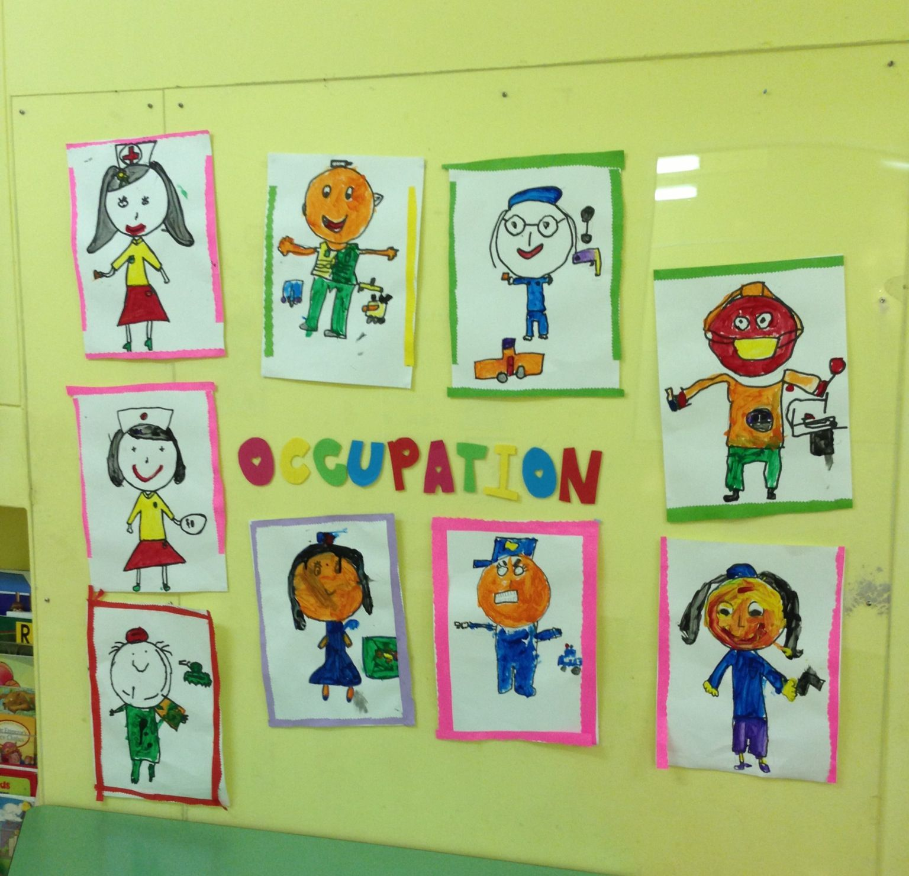

Animal dance

This activity helps children develop their dancing skills with diverse music. This activity teaches children about the animals through a storybook and dancing. Children will first listen to an Indigenous story about the animals in this activity. Then children dance with the different animal action songs. One of the songs will be an Indigenous animal’s song. Children will need to follow the music to make a different animal movement. Children will be encouraged to dance in the group with a peer. During the dancing time, children will also have the opportunity to choose one of their favourite multicultural musical instruments to dance with.

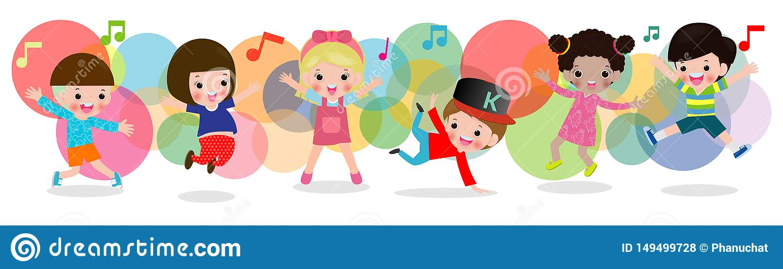

Colour Sorting

This activity helps children to learn colour through the children book and playing activity. At the beginning of this activity, the educator will share a picture book about diversity with the children and also set up some other children's books about the colours of the playing area. After reading the book, the educator will teach children different colours with the word’s cards. Then the educator will set up the table with different colour containers, and each container will be labelled in English and Indigenous language. Children will be offered different-colored Legos, pompons, and small sorting bears. The educator will clarify the colour sorting activity’s game rule, and encourage children to sort different toys by colour.

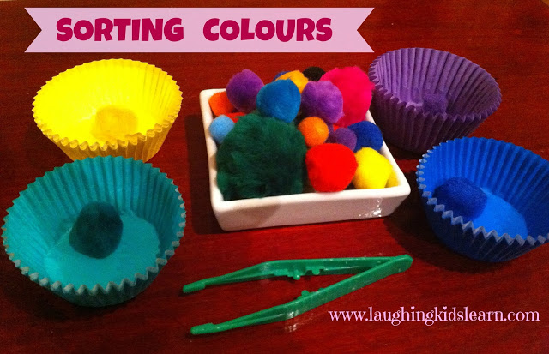

* + **working place play-based learning plan** 
    - **kindergarten**

Vegetable Self-portrait

This activity can help children to learn how to draw different vegetables, and children also can learn how to create a self-portrait using different vegetables. At the beginning of the activity, the teacher read a children's book about vegetables and though children how to draw different kinds of vegetables. After the story, the teacher encouraged children to draw a self-portrait with water paints in the art area. At the end of the activity, the children also shared their artwork in the group.

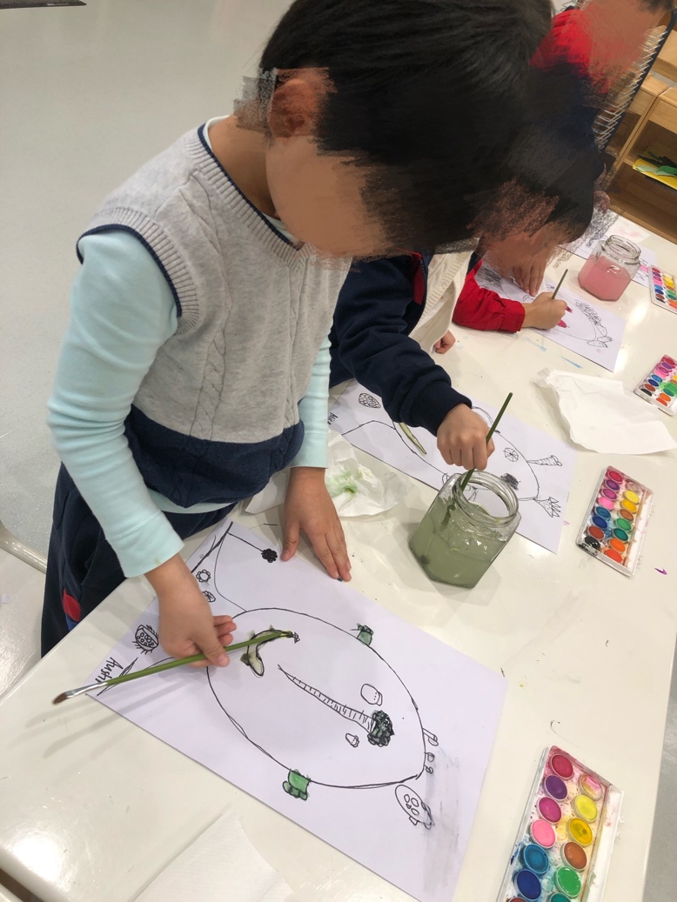

Baking activity

This activity can help children to explore the joy of baking by learning to use different baking tools. At the beginning of the activity, the teacher shared a baking video and summarized the baking strategies with the children. After the video, the teacher showed the children all the ingredients and baking tools. After that, the teacher encouraged all the children to follow the instructions to make their own bread. The teacher also sent the bread to the family at the pickup time.

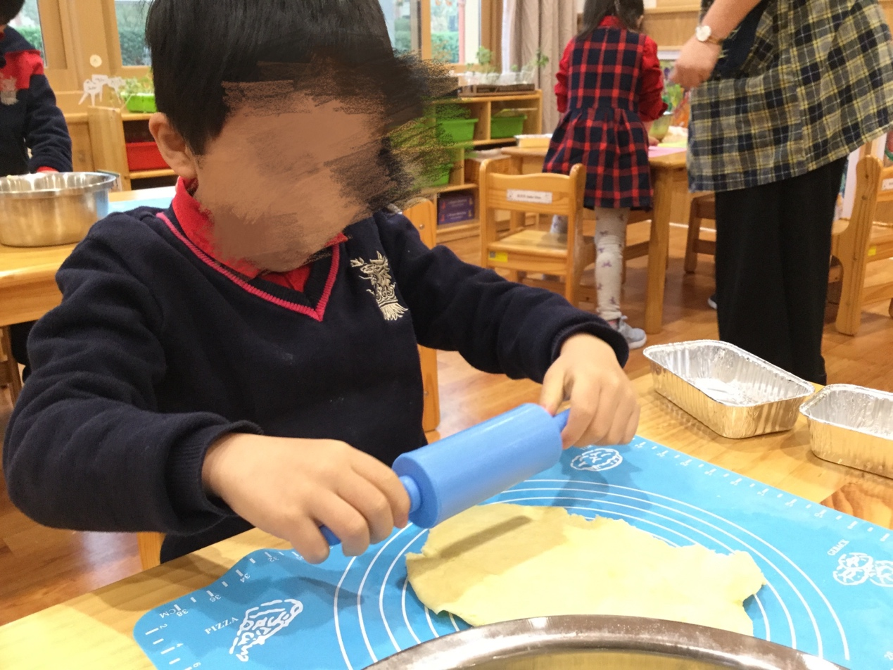

**preschool**

Outdoor painting

* This activity can help children express their spring observations through the artwork. At the beginning of the activity, the teacher shared the storybook about the spring. The teacher also invited children to make some observations of the outdoor environment. After that, the teacher encouraged children to draw a picture about the spring by using all the outdoor art materials. At the end of the activity, the teacher displayed children’s artwork in the classroom.

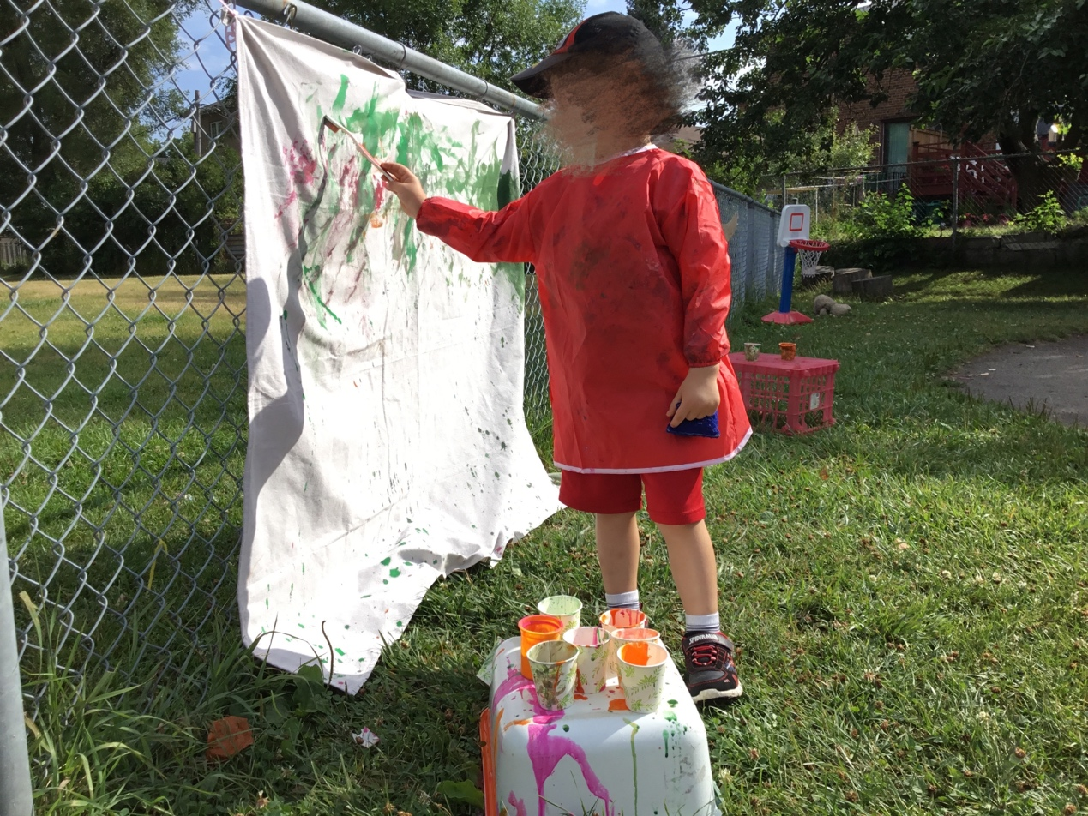

Blowing bubbles

This activity can help children to develop their sensory skills by playing with soapy water. Children were encouraged to explore the soapy water during the free playtime. The children first made the soapy water under the teacher’s help. After that, the children learned to use the straw to blow the bubble in the group.

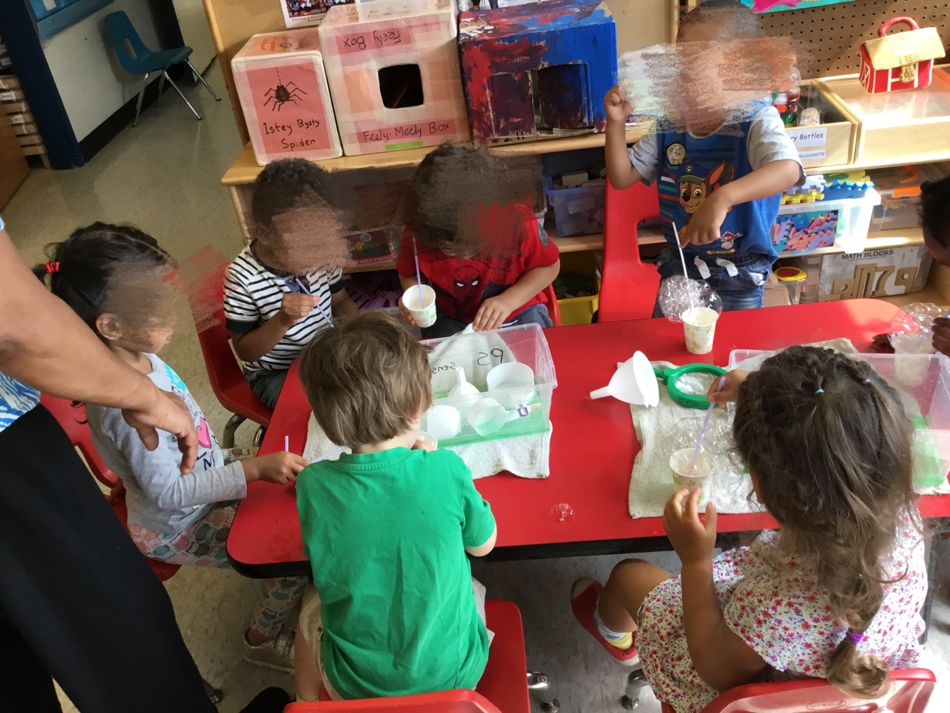

* Academic course work
  + Significant Assignment

**Assignment 1: Recommend Books for Young Children**

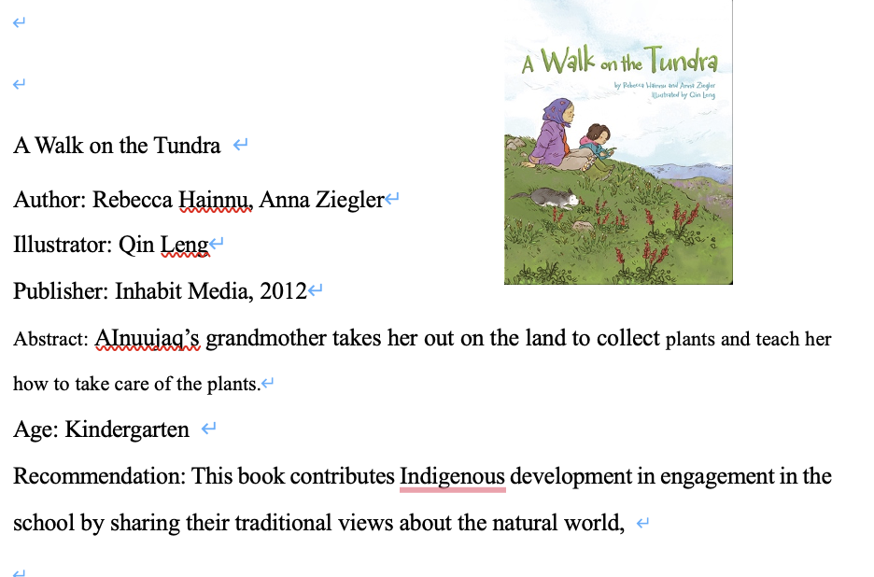

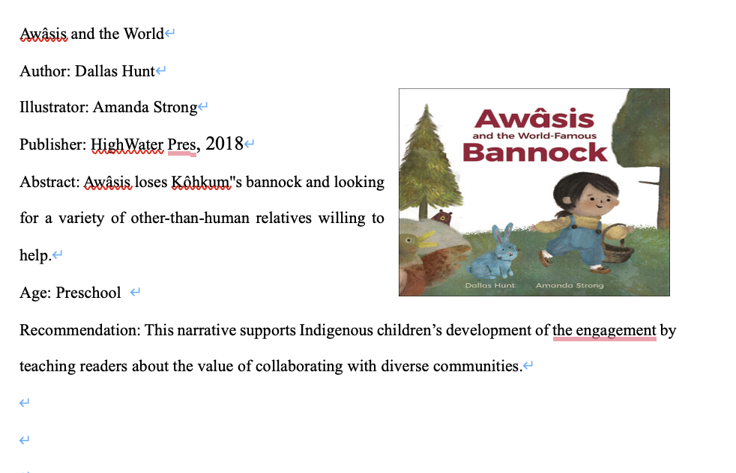

Diverse children's literature is commonly regarded as writings that explore themes about ethnicity, race, culture, and language. Using diverse children's literature can support groups that have been exposed to systemic bias, because those books not only recognize different national’s identities, but also assist different groups of children in making a smooth transition from their home to school.

I have shared eight children’s books for the Indigenous family in this assignment. The Indigenous people face many inequalities in this society, and health inequality is the majority of the inequality they suffer from. This assignment aims to support the health development of Indigenous children by using a variety of Indigenous children’s books.

**Assignment 2: The Home Instruction for Parents of Preschool Youngsters (HIPPY) Program Review**

|  |
| --- |
| **Developer**: HIPPY was originally established in 1969 at Hebrew University in Israel; the Mothers Matter Centre is the developer for HIPPY Canada |
| **Target audience**: HIPPY supports vulnerable and isolated mothers in their critical role as their child’s first and most important teacher by working in the home visiting way. |
| **Goals and the Topics:** HIPPY strengthens families and communities by empowering mothers to actively participate in Canadian society, prepare their children for success in school and life, and partner with parents to prepare their children for school. |
| **Teaching methods and learning activities:** HIPPY delivers the training by home visiting and doing the role play with parents, which curriculum has 30 weekly packets of developmentally appropriate learning activities. |
| **The duration**: 3 years with 30 weeks for each year from age 3 to age 5 |
| **Delivery format:** Home visiting; online training during the epidemic. |
| **Sponsors or host agencies:** https://mothersmattercentre.ca/hippy-site-locations/ |
| **The costs:** Costs to the community agency are approximately $3,000 per child per year. HIPPY is free to the parents who participate. |
| **The language of instruction:** Varies by the provider |
| **Admission policy**: Varies by the providers |
| **Feedback and assessments, if available, from parents:** https://www.youtube.com/watch?v=04dAgQBV1-o |
| **The methodologies used by the researchers to assess the effectiveness of the  program and the extent to which it met the needs of participating families:** It's an evidence-based program with much peer-review research done by the different research teams in various locations in the world in the past 20 years. 1. Johnson, U. Y., Martinez-Cantu, V., Jacobson, A. L., & Weir, C.-M. (2012). The Home. Instruction for Parents of Preschool Youngsters Program’s Relationship with Mother and School Outcomes. Early Education & Development, 23(5), 713–727. https://doi.org/10.1080/10409289.2011.596002  2. Bernhard, J. K.. (2013). Re-situating Canadian Early Childhood Education. New York: Peter Lang. (pp. 106- 124).  Nathans, L., Nievar, A., & Tucker, M. (2020;2019;). The effects of the home instruction for parents of preschool youngsters program on latino parenting using propensity score analysis. Journal of Social Service Research, 46(5), 726-739. <https://doi.org/10.1080/01488376.2019.1656144>  3. Nievar, A., Brown, A. L., Nathans, L., Chen, Q., & Martinez-Cantu, V. (2018). Home visiting among inner-city families: Links to early academic achievement. Early Education and Development, 29(8), 1115-1128. https://doi.org/10.1080/10409289.2018.1506229  4. Payne, T., Joseph, R. A., Yampolskaya, S., & Vatalaro, A. (2020). Florida HIPPY parents successfully prepare their children for kindergarten. Early Childhood Research Quarterly, 53, 650-657. https://doi.org/10.1016/j.ecresq.2020.07.007 |

One of ECE's job responsibilities is to provide different resources based on the needs of each family. The ECE needs to have the ability to search for resources in order to provide better support to families. Through this assignment, I have learned how to find different programs to improve the parenting skills of families.

Many immigrant families live in poverty and face challenges in childcare, and their diverse life experiences can be a barrier for them to achieve their high expectations of their children's education. The Home Instruction for Parents of Preschool Youngsters program can support new immigrant mothers to work as the first teacher in helping children to get ready for school at the preschool age.

Assignment 3: Home School Literacy Newsletter

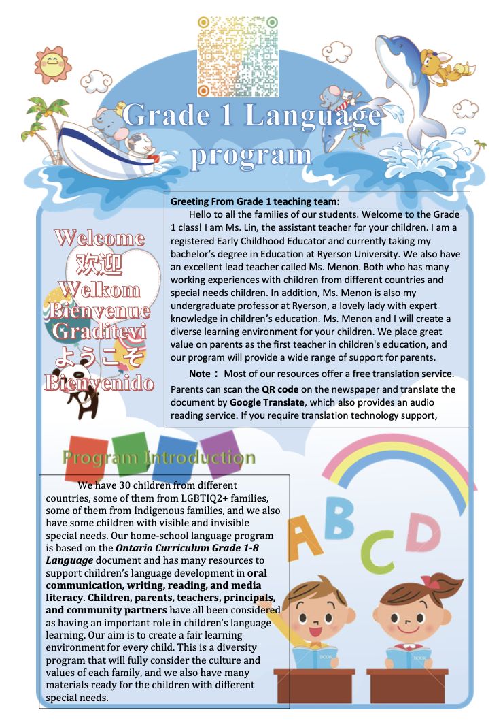

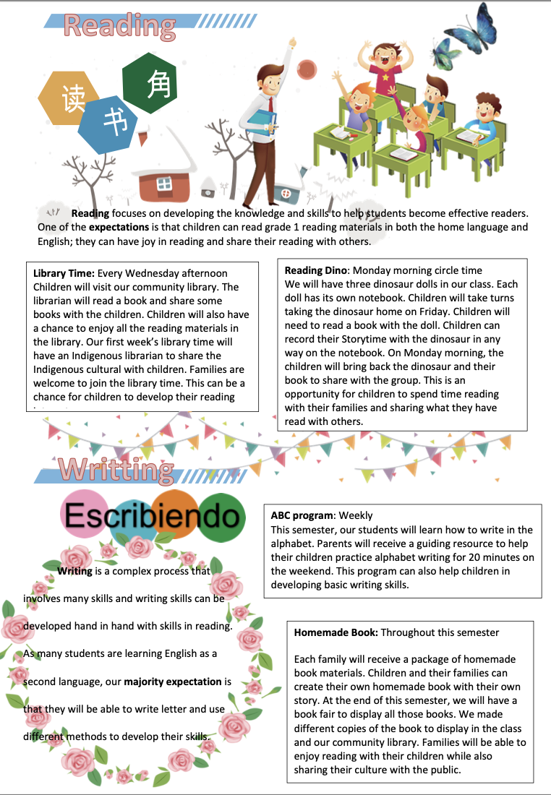

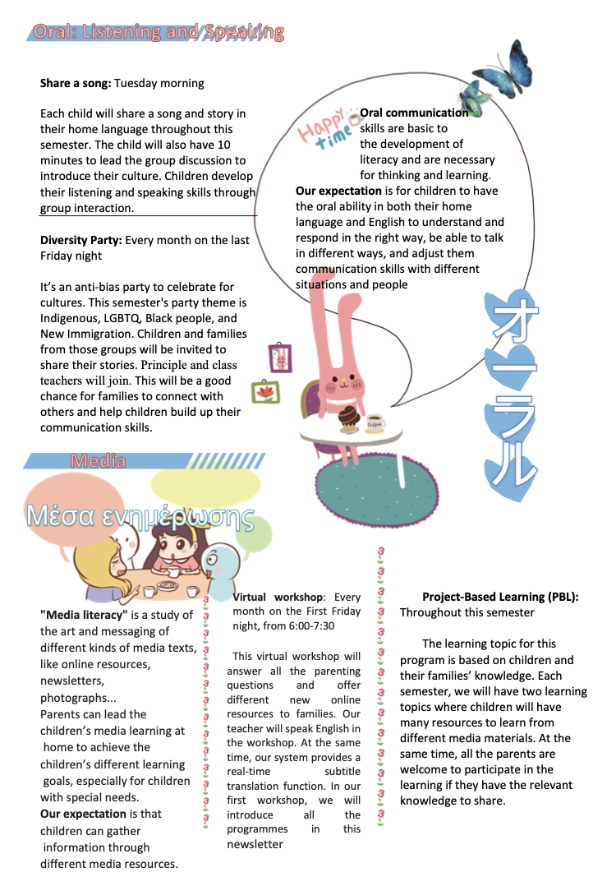

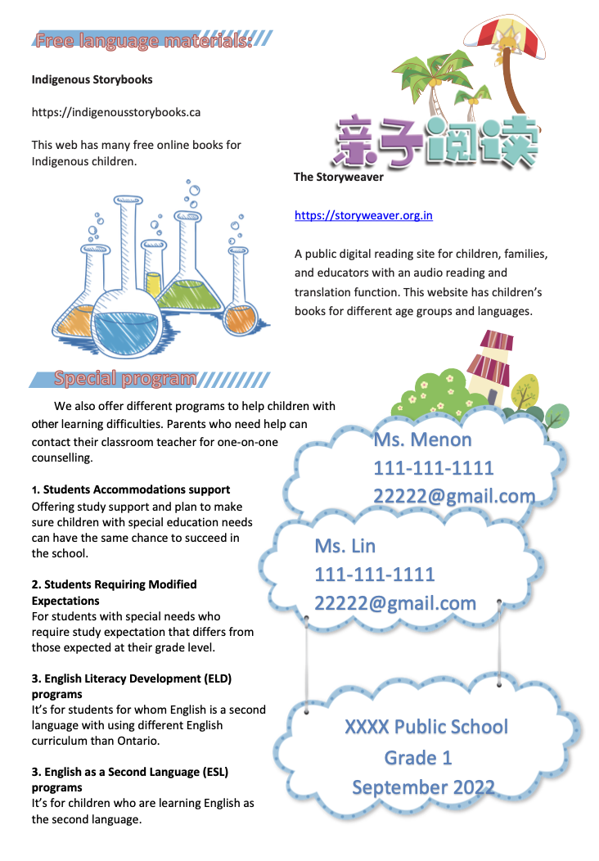

Language is an essential skill that a child can develop at home and school in a language-rich environment. Having a variety of language programs available at the start of the school year can assist students and their families make a smooth transition from kindergarten to Grade 1. I have learned how to plan diverse home school programs to support children’s literacy development.

* + Annotated Bibliography

Fostering Literacy Success for First Nations, Métis and Inuit Students.

Toulouse, P. (2013). Fostering literacy success for First Nations, Métis and. Inuit students. What Works. Research into Practice, 45.

This article discusses about the importance of embracing a bilingual approach for Indigenous children in the school teaching environment. The author shares many teaching strategies in supporting the language development of Indigenous students. This article helps me learn how to create a culturally appropriate learning environment for Indigenous children. I can use it as guidance for my future career as an ECE.

Funds of Knowledge for Teaching: Using a Qualitative Approach to Connect Homes and Classrooms

Moll, L. C., Amanti, C., Neff, D., & Gonzalez, N. (1992). Funds of knowledge for. teaching: Using a qualitative approach to connect homes and classrooms. Theory into Practice, 31(2), 132-141. <https://doi.org/10.1080/00405849209543534>

This article discusses how the family’s funds of knowledge can support children’s development. The study from this article indicates that considering the funds of knowledge into the teaching curriculum can reduce the insularity of classrooms, and contribute to the academic content and lessons. This article has taught me that I can create an inclusive learning environment by bringing family funds of knowledge into the curriculum plan.

Towards creating inclusive environments for LGBTIQparented families in early childhood education and care settings: A review of the literature

Liang, X. M., & Cohrssen, C. (2020). Towards creating inclusive environments for. LGBTIQ- parented families in early childhood education and care settings: A review of the literature.*Australasian Journal of Early Childhood, 45*(1), 43-55. <https://doi.org/10.1177/1836939119885304>

This article discusses about how to support the LGBTIQ family in the school environment. The author identifies the key influences on the lived experiences of LGBTIQ parents and their children in the context of early learning centres. This article helps me learn how to create an inclusive learning environment for LGBTIQ families. I can use this as guidance to support LGBTQ families.